Niagara County Office for the Aging

**Medicare Savings Program (MSP)**

You may be eligible to get help paying your Medicare premiums and you

may also get help paying for Medicare Part A (Hospital Insurance) and Medicare Part B (Medical Insurance) deductibles, coinsurance, and copayments.

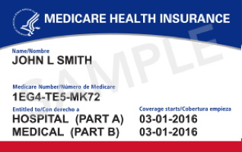

If you are a Medicare recipient with gross Monthly income of

$1456 or less for a single person or

$1960 or less for a married couple

YOU MAY BE ELIGIBLE!

Call the Office for the Aging’s NY Connects Program at **716-438-3030** to speak to a Health Insurance Counselor for free, unbiased assistance with Medicare and to find out more about the Medicare Savings Program.

Niagara County Office for the Aging

111 Main St., Suite 101

Lockport, NY 14094

716438-3030